Organic production and Fairtrade of basmati rice enables Indian farmers to improve their livelihoods while safeguarding the environment.

This manual for extension staff is designed to support organic basmati farmersto increase profitability, diversify farming systems and reduce water consumption and greenhouse gas emissions, but also to provide information onfarm economy and certification.

**Table of Contents**

1. Introduction 3

1.1. Why organic basmati? 3

1.2. Organic farming 4

2. Organic basmati farming 5

2.1. Soil Management 6

2.1.1. Climate and soil type 6

2.1.2. Crop rotation 6

2.1.3. Green manure 6

2.1.4. Land preparation 7

2.1.5. Intercropping 7

2.2. Basmati nursery 8

2.2.1. Varieties and seeds 8

2.2.2. Nursery preparation 8

2.2.3. Seed treatment and sowing 8

2.2.4. Nursery management 9

2.2.5. Transplanting 9

2.2.6. Seed production 10

2.3. Water management 11

2.3.1. Sustainable irrigation 11

2.3.2. Alternate wetting and drying 11

2.4. Organic fertilisers 12

2.4.1. Farmyard manure 12

2.4.2. Compost 12

2.4.3. Biogas slurry 14

2.4.4. Natural mineral fertilisers 15

2.4.5. Biofertilisers 15

2.5. Intercultural operations 15

2.5.1. Weeding 15

2.5.2. Clipping 15

2.6. Pest and disease management 16

2.6.1. Prevention and control 16

2.6.2. Important pests 17

2.6.3. Important diseases 17

2.6.4. Biopesticides 18

2.6.5. Biopreparations 18

2.7. Harvest and post-harvest 19

3. System of Rice Intensification (SRI) 20

4. Diversifying farming systems 21

4.1. Organic soybean farming 22

4.1.1. Varieties and seeds 22

4.1.2. Land preparation 22

4.1.3. Sowing 22

4.1.4. Irrigation 22

4.1.5. Weed management 22

4.1.6. Pests and diseases 22

4.1.7. Harvesting and post-harvest 22

4.2. Organic wheat farming 23

4.2.1. Varieties and seeds 23

4.2.2. Land preparation 23

4.2.3. Sowing 23

4.2.4. Irrigation 23

4.2.5. Weed management 23

4.2.6. Pests and diseases 23

4.2.7. Harvesting and post-harvest 23

5. Farm economy 24

5.1. Improving farmer’s income 24

5.2. Record keeping 25

5.3. Profitability of organic basmati 25

6. Certification 26

6.1. Organic 26

6.2. Internal Control System 27

6.3. Fairtrade 28

7. Role of women 29

8. References 30

9. Annex 31

9.1. Work Calendar 31

9.2. Record keeping 32

*1 ha = 15 bigha = 37.5 nali*

*1 ton = 10 quintals*

# Introduction

## Why organic basmati?

There is a growing demand for organically produced food – including basmati rice – worldwide and organic farming is continuously gaining importance.

The negative impacts of conventional agriculture and the increasing use of chemical fertilisers and pesticides lead to several harmful effects to the environment. The indiscriminate use of pesticides kills many beneficial insects and other animals, and chemicals heavily pollute water resources. Soil fertility reducesdue to monocropping and the overuse ofchemical fertilisers. Moreover, major health implications for farmers and farm workersdue to thespraying of pesticides and the drinking of polluted water areadditional severe consequences of conventional farming.

**Rice facts**

* Staple food for 4bn people worldwide
* Income source for 140m households
* Grown on 12% of arable land
* Uses 34-43% of total irrigation water
* Emits 10% of greenhouse gases from agriculture
* Consumes large amounts of chemical fertilisers, pesticides, herbicides

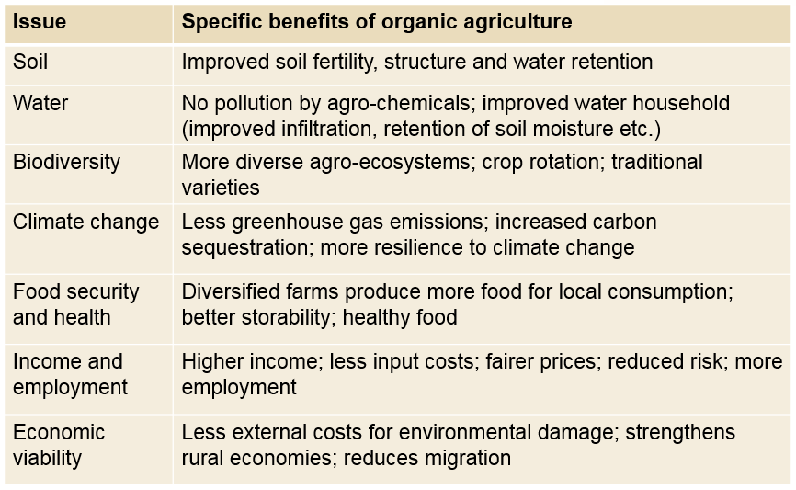In contrast, organic agriculture sustains the health of ecosystems, soils and people by relying on ecological processes, biodiversity and cycles adapted to local conditions rather than the use of external inputs with adverse effects. The benefits of organic basmati production are summarised in Table 1.

Table 1: Advantages of organic basmati production

Global paddy rice production depends on high water input as well as it is responsible for substantial emissions of greenhouse gases, which contribute considerably to climate change (see *Rice facts* below). Towards a more eco-friendly production water demand and greenhouse gas emissions need to be reduced - also in organic basmati production.

## Organic farming

Figure 1: Multiple benefits of organic agriculture (Source: IFOAM)

As per the *International Federation of Organic Agriculture Movements (IFOAM)* organic farming roots in four principles:

* **Principle of health;**sustains and enhances the health of soil, plant, animal, human and plant as one and indivisible.
* 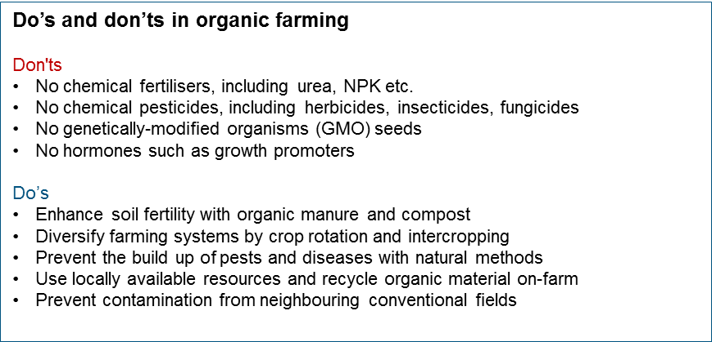**Principle of ecology;** bases on living ecological systems and cycles and works

Box 1: Do's and don'ts in organic farming

with them, emulates them and helps sustain them.

* **Principle of fairness;** builds on relationships that ensure fairness with regard to common environment and life opportunities.
* **Principle of care;** manages in precautionary and responsible manner to protect the health and well-being of current and future generations and the environment.

Organic Agriculture combines tradition, innovation and science and asks to strictly follow the national regulations and organic standards of the respective country (see *6. Certification*).

In general, no chemical fertilisers, pesticides, genetically-modified organisms and hormones are allowed in organic farming. Organic agriculture focuses on enhancing soil fertility, diversifying farming systems, preventing the build-up of pests and diseases and using locally available resources and recycle on-farm, see Box 1 above.

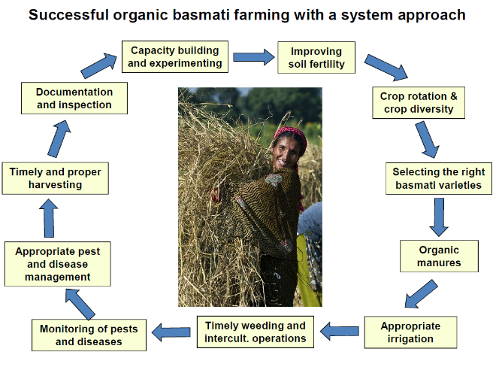

# Organic basmati farming

Successful organic basmati farming is best promoted through a systemic approach thatcombines different activities:improving soil fertility, crop rotation and diversification, organic fertilisation, appropriate irrigation, weeding, pest and disease management as well as timely and proper harvesting, see Figure 2. This chapter highlights best organic basmati production practices that were developed and tested in the foothills of the Indian Himalaya (Nainital District in Uttarakhand).

Figure 2: Successful organic basmati farming

## Soil Management

### Climate and soil type

Basmati is a rainy season (*Kharif: June – October*) crop and optimum growing temperatures range between 20°C and 35°C. Cooler temperatures (e.g. in higher altitudes) affect crop development and risk that the crop is not maturing well. Basmati is harvested at the beginning of the winter season (*Rabi: November – March*) thus making space for a second crop.

The cropprefers heavy soils – clay, clay loam and loamy soils – which can hold water for a long period. Stagnant water is however harmful for the crop. The soil should be neutral, with a pH ranging between 5.0 and 8.0.Saline and alkaline soils adversely affect basmati growth.

### Crop rotation

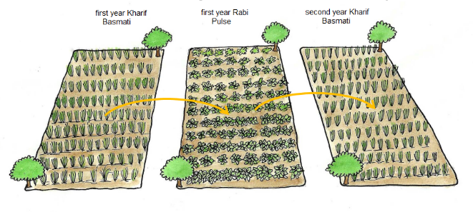It is important that organic basmati is grown in a locally suited crop rotation, see Figure 3. Crop rotation improves and maintains soil fertility and ensures balanced nutrient contents in the soil. A proper crop rotation also prevents the build-up of pests, diseases and weeds. For more information refer to *4. Diversifying farming systems*.

### Green manure

Green manure is a crop grown with the purpose to improve soil fertility.Ideally, a legume crop is used that can fix nitrogen from the atmosphere.

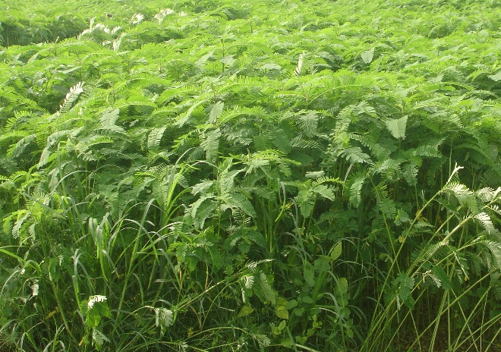Dhaincha (*Sesbaniaspp.*) or Sanai (*Crotolaria spp.*) are well suited legumes to grow as green manures, others like mung or urad are good alternatives, too.

In crop rotation, after harvesting the Rabi crop green manuring(*summer crop: March – May*) can fill the gap until basmati is transplanted into the plot. Before flowering, the green manure crop is directly incorporated into the soil to improve fertility, especially nitrogen contents in the soil.

Figure 3: Main principle of crop rotation (Source: FiBL, 2011)

### Land preparation

Around 3 weeks before transplanting basmati, in June, the field is ploughed in dry condition.

Sufficient organic manure needs to be applied to the field, however, the amount depends on the previous green manure crop.

**Application of compost (fresh)**

* 23 -26 quintals per bigha (35 - 40 tons/ha)

Or if green manure is applied

* 5.5 -6.5 quintals per bigha (8.5 - 10 tons/ha)

Or if available, better use vermi-compost

* 12.5 - 13 quintals per bigha (19 - 20 tons/ha)

Just 3 days before transplanting, after submerging the field with 5–10 cm standing water,the field is puddled 4 to 5 times to create mud and to level the field.

Bunds around the field border avoid water inflow from conventional fields. In case of chemical spraying in neighbouring fields, sugarcane, maize or Dhaincha (*Sesbania spp*.) can be planted as a boarder crop to avoid contamination with chemicals.

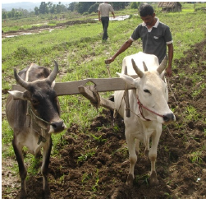

**How to grow green manures**

* Prepare the land
* Sow 2 kg seed per bigha (30 kg per ha)
* When plants reach 3 feet height or before flowering, cut the crop and mix it into the soil

### Intercropping

Basmati can be intercropped with finger millet and soybean. Finger millet can be grown in rows between the basmati.Soybean is intercropped on ridges while the field is not permanently flooded, usually two rows basmati following one row soybean.

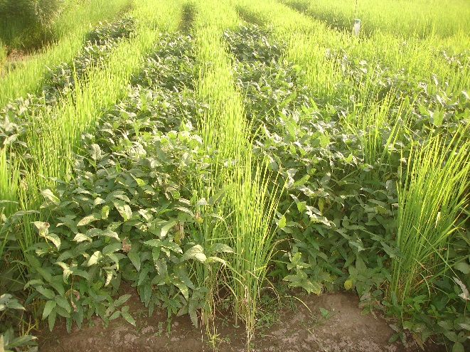

## Basmati nursery

### Varieties and seeds

Only varieties that are recommended for the area and which have market demand should be cultivated. Moreover, seeds need to be authorised for organic farming.

Use only seeds supplied by the buying company or from own seed production!

At the moment available and suitable basmati varieties areDehradooni (Type -3) and Taraori (HBC-19). Dehradoonimatures earlier and suited for higher altitudes, as compared to Taraori, see Table 2.

*Table 2: Characteristics of basmati varieties*

|  |  |  |
| --- | --- | --- |
|  | **Dehradooni**  **(Type – 3)** | **Taraori**  **(HBC – 19)** |
| Duration of plant growth | ~ 135 days | ~ 150 days |
| Suitable conditions | Higher altitudes | Lower altitudes |
| Growth | Shorter, less straw | Taller, more straw |

### Nursery preparation

The nursery is prepared between first and second week of June. For one bigha basmati a nursery of 30 -35m2 (mud beds:3 strips of 8m x 1.25m) is needed. For the **System of Rice Intensification (SRI)**, only 0.75- 1m2 (200-300g seed) of nursery is required. Best is to make bunds all around the nursery.

After harvesting the Rabi crop the nursery area should be solarised by spreading transparent plastic sheets for 3 to 4 days to reduce soil-borne diseases and weeds.

In each nursery strip 25-30kg (2-3 baskets) properly decomposed organic manure and 25g zinc sulphate is best applied.

### Seed treatment and sowing

1) Dip seeds in 15% saline solution (1.5kg salt in 10 litres of water). Remove all floating seeds. Rinse and soak the seeds in clean water for 24hours.

2) Treat the seeds with beneficial microbes. For 1kg of seed apply 5g Trichoderma and 5g Pseudomonas **or** 10g Pant Biogent-3.

3) Make a thick layer of seeds and cover them with wet gunny bags for 36 -48 hours for germination. Sprinkle water to ensure that seeds are moist all the time.



For onebigha basmati 1.5kg seeds are needed. Thus, in each of the 3 mud beds/strips 500g germinated seeds are sown.

### Nursery management

At 15 days after sowinga mixed solution of 10%vermi-wash, 10% cow urine, 10g/litretrichoderma, 10g/litre pseudomonas and 0.5% neem oil is sprayed in the nursery. After one week the spraying is repeated.

Yellowing of rice due to zinc deficiency (Khiara) is controlled by the application of bio-preparation with zinc sulphate (see Figure 10, page 19). The bio-preparation is sprayed in the nursery at 10 and 20 days after sowing.

The most prominent pest during nursery stage is stem borer. Neem oil is sprayed to control stem borer and pheromone traps are installed (1 trap per 100m2).

Clipping is done if plant height is exceeding 1 feet. Moreover, clipping is recommended before transplanting to remove eggs of stem borer and diseased parts of leaves.

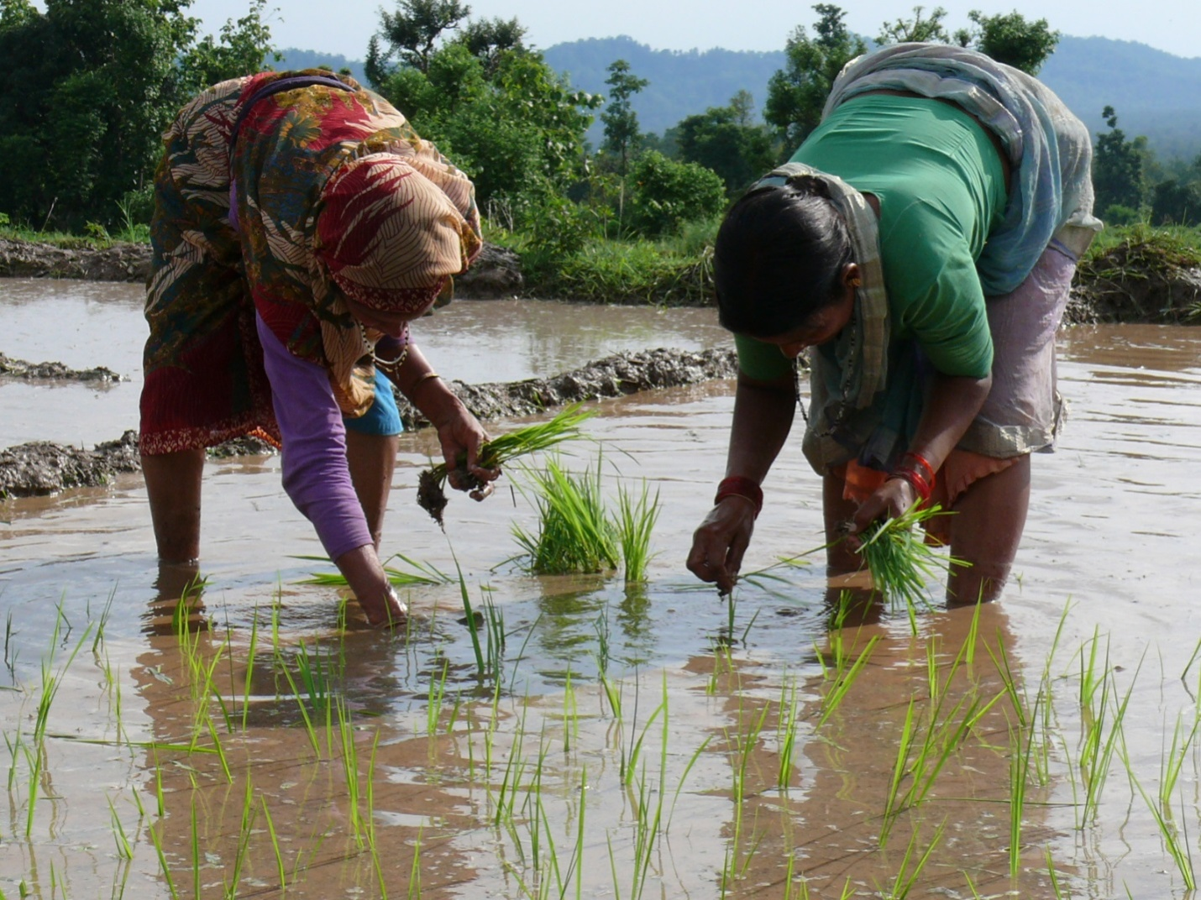

These measures help to grow strong and healthy seedlings.

### Transplanting

The seedlings are transplanted 20 to 25 days after sowing; 2-3 seedlings at 15 x 15 cm after dipping their roots for 10 minutes in a solution of 10gTrichoderma and 10g Pseudomonas.

If *Phosphorus Solubilising Bacteria* (PSB) and Azotobactorare available use 10g eachto treat the roots.

### Seed production

***What is hybrid seed?***

*Many rice varieties are hybrid seed, seed of the first generation (F1) from a controlled cross-pollination between two different inbred lines (selected for many generations). A hybrid shows high yield potential (heterosis effect), but performance decreases drastically if recultivated.*

Rice is a self-pollinating crop and traditional seed rice production involves normally 3 steps. Firstly, seed selection or the selection of rice panicles for recultivation in the next season. The selection of fully mature, uniform, healthy and disease free panicles is essential to obtain good quality seed. Secondly, the harvested panicles for seed production need to be dried properly, best under shade, before being stored. Proper seed storage is key to maintain seed quality to the time of recultivation. Seeds should be stored in a cool, dry and airtight container, e.g. a clay pot, see Figure 4.

Before sowing a **germination test** is appropriate:

1. Soaking: Count 100 seeds and soak them in water for 24 hours.

2. Incubate: Wrap the seeds in a moist paper or cloth and keep for 2 days.

3. Count germinated seeds: The number of germinated seeds is the germination rate.

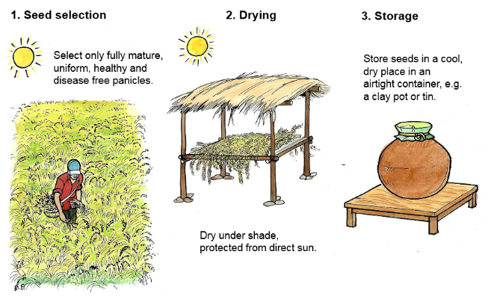

Figure 4: Basmati seed production (Source: FiBL, 2011)

## Water management

### http://www.climatetechwiki.org/sites/climatetechwiki.org/files/images/extra/awd_image.pngSustainable irrigation

After transplanting a level of 3-5cm water is kept for 3 days, then drained to the point of saturation (no flooding). Then, drying of the soil is allowed until the point when the soil is drying up (no deep cracks yet!) before irrigated again.

During tillering, ear emergence, and flowering sufficient irrigation is of upmost importance, whereas during the remaining crop stages, life-saving irrigations, in case of drought, suffice.

### Alternate wetting and drying

Alternate wetting and drying (AWD) method saves water and reduces greenhouse gas emissions while maintaining yields. The AWD practice involves periodic drying and re-flooding of the rice field.

Two weeks after transplanting the field is left to dry out until the water level is at 15cm below the soil surface. Then the field is flooded again to a water depth of 3 -5 cm before drying again. This scheme is repeated until flowering time. During flowering the field is maintained flooded at a water depth of 3 -5 cm, see Figure 5.

**Benefits of AWD method**

* Reduces water use by up to 30%
* Reduces methane emissions by an average of 48%
* Maintains yields and saves money on irrigation, thus increases net returns

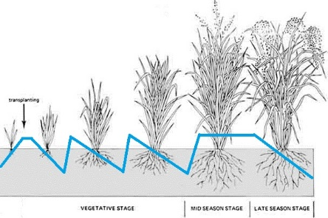

The water level is monitored by a field water tube – a 30cm length of 15cm diameter pipe with drilled holes – which is sunk into the rice field for 20cm, see picture below.

The alternate wetting and drying method requires however proper land levelling and weed management.

Figure 5: Water level during basmati growth stages (Source: adapted from FAO)

## Organic fertilisers

A fertile soil with sufficient nutrients is assured through the application of sufficient organic fertilisers. The basmati crop requires the following nutrient quantities, see Table3.

*Table 3:Nutrient requirements of basmati and nutrient contents of different organic fertilisers*

|  |  |  |  |
| --- | --- | --- | --- |
|  | **N** | **P** | **K** |
| **kg/bigha (kg/ha)** | 6.67 (100) | 4(60) | 2.67(40) |
| Farmyard manure (dry) | 0.4 -1.5% | 0.3 -0.9% | 0.3 -1.9% |
| Compost (dry) | 0.5 -1.0% | 0.4-0.8% | 0.8 -1.2% |
| Local compost(tested) | 0.5% | 0.2% | 0.7% |
| Vermi-compost | 0.6 -1.5% | 0.4-0.9% | 0.5-1.0% |
| Local Vermi-compost (tested) | 1.2% | 0.3% | 1.1% |
| Biogas slurry | 1.5 -2.5% | 1.0 -1.5% | 0.8 -1.2% |

In organic farming nutrient requirements are supplied through green manure and various sources of organic fertilisers described in the following.

### Farmyard manure

Many basmati farmers keep livestock, thus farm yard manure is a cheap and efficient organic fertiliser. However, the handling of manure has enormous effects on its quality. The following measures contribute to improve the quality of farmyard manure:

* Livestock should be kept at night in a stable or defined area with sufficient bedding material which enables to absorb dung and urine.
* Manure should be collected and stored under roof or plastic to protect it from sun and rain.
* Manure is best used for composting, which reduces weeds, pest and diseases in the manure.
* Manure should be incorporated immediately into the soil after application to avoid nutrient losses.

An easy way to apply manure to a field is by grazing livestock directly in the field after the harvest of the crop.

**Cow urine** is a nitrogen rich fertiliser and should be collected separately.

### Compost

Compost is a high value organic fertiliser from a controlled decomposition of plant material and organic manures. There are three types of composting:

* Batch fed systems where all material is set up at once, called NADEP-compost
* Continuously fed systems where material is added again and again
* Vermi-compost, a continuously fed system that uses earthworms

**Compost** is set up in a heap or pit that vary in location, size and timing and depends on the composting material available. This can be crop residues, weeds, twigs, leaves, fodder residues, dung, biogas slurry, kitchen waste and by-products from processing. However, important is to take care that no plastic gets into the compost.

**Compost mixture**

* 1/3 sturdy and bulky material; chopped twigs, roots etc.
* 1/3 medium to fine material rich in *carbon*; straw, dry leaves, dry weeds, fodder residues etc.
* 1/3 fine material rich in *nitrogen*; dung, green leaves, kitchen waste etc.

**Steps in compost making**

1. Chop coarse material

2. Put at the bottom of the heap or pit twigs and other coarse material

3. Pile up alternate layers of carbon rich and nitrogen rich material

4: Spread in every alternate layer some rock phosphate or wood ash

5. Sprinkle the layers of coarse material with cow dung slurry or biogas slurry

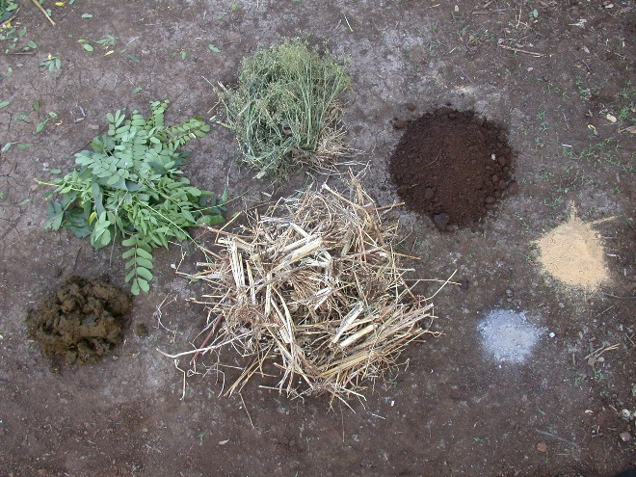6. Add thin layers of soil

7. Cover the heap or pit with a 10cm thick layer of straw or leaves in the initial stage and with sacks or plastic sheet in the final stage

8. Keep the compost moist. If the compost gets to dry sprinkle water over it.

9. Thoroughly mix the compost heap or pit by turning it after 2-3 weeks and after 1-2 months.

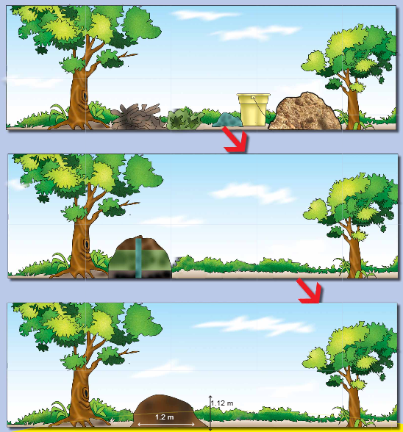The compost heap or pit produces lots of heat through the decomposition of organic material and manure by microorganisms. This heat helps to kill weed seeds, pests and diseases.

A **vermi-compost** is continuously fed with plant material and organic manure which is decomposed by earthworms into excellent manure.

**Vermi-wash** is a liquid fertiliser or plant topic. Water is sprinkled over the compost heap or pit and excess water collected in a container beneath.

Figure 6: The process of making compost

### Biogas slurry

Organic biogas production combines organic agriculture with renewable energy production to reduce greenhouse gas emissions.

A biogas plant produces from biomass and manurea gas rich in methane which can be used for cooking and lighting. Biogas slurry is a valuable by-product of the biogas production. Biogas slurry used as fertiliser supplies essential nutrients, enhances water holding capacity and soil aeration, accelerates root growth and inhibits weed seed germination.

There are three types of biogas slurry, see Table 4.

*Table 4: Types of biogas manure (slurry)*

|  |  |  |  |
| --- | --- | --- | --- |
| **Parameter** | **Liquid** | **Semi-dried** | **Dried** |
| Solid content | 6% | 15 -20 % | 20 -30 % |
| pH value | 8 - 9 | 7 - 9 | 7 - 8 |
| Usagevalue | Best form | Second best | less |
| Other features | 1.8% nitrogen | - | Micro-nutrients, lessnitrogen |

The output from the biogas plant, the biogas slurry is caught and stored in a collection tank to the time of application to the field, see Figure 7.

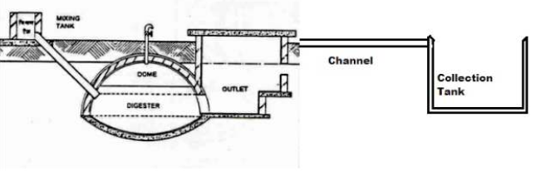

Figure 7: Collection tank attached to a biogas plant

**Steps in biogas slurry collection**

1. The slurry tank is best of concrete to retain moisture and prevent leaching of nutrients.

2. The slurry tank should be closed to avoid direct sunlight.

3. The slurry can be directly applied to the field by using a bucket or a pale.

4. The slurry can be mixed with running irrigation water or directly sprinkled to the field.

5. If there is no standing crop, the slurry should be directly incorporated in the soil to avoid losses.

6. If slurry is sprayed or applied to a standing crop it should be diluted with water (1:1).

7. Semidried or dried slurry can be used for top-dressing, but time of application needs to be considered carefully.

8. The slurry can be mixed with compost (1:4) and be used for vermi-composting.

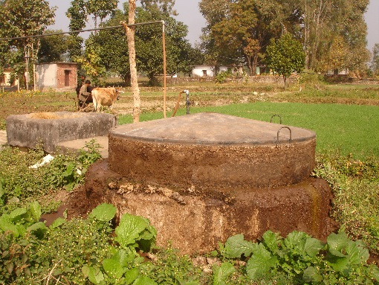

### Natural mineral fertilisers

A limited use of natural mineral fertilisers is allowed in organic farming.

Rock phosphate (15 - 30% P2O5) and wood ash can be added to the compost rather than directly to the soil for best absorption. Muriate of potash (ca. 60% K2O), a natural salt, should only be applied if there is deficiency of potassium in the soil (make a soil test). For zinc deficiency, zinc sulphate (25kg/ha) can be applied during soil preparation. Gypsum can be applied in sulphur deficient soils, whereas lime is used in very acidic soils to improve pH.

If available, apply 2 - 3 quintals vermi-compost per bigha after the first weeding.

### Biofertilisers

Biofertilisers contain beneficial microorganisms that increase nutrient availability in the soil. However, organically managed soils already contain most beneficial microorganisms. Especially during the conversion time from conventional to organic farming biofertilisers may help to revive the soil.

Biofertilisers include:

* Rhizobium bacteria, which allow leguminous crops to fix nitrogen.
* Azotobacter and Azospirillum bacteria, which fix nitrogen in the soil.
* 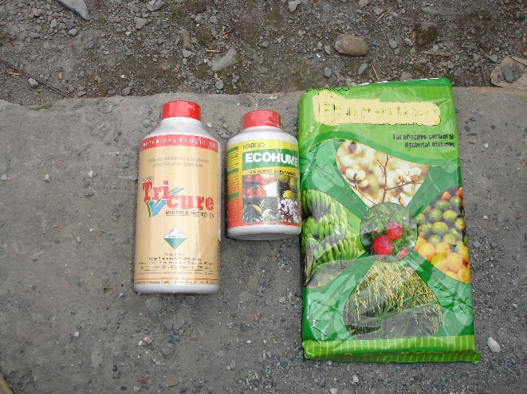*Phosphorus Solubilising Bacteria* (PSB), which help to make phosphorus better available in the soil.
* Mycorrhiza fungi, which associate with the roots of many plants and help take up water and nutrients.

## Intercultural operations

### Weeding

Mainly weeding and harrowing are performed as intercultural operations. These two operations happen simultaneously in the field and are done at 20 - 25 days after transplanting, at 40 - 45 days after transplanting and can be repeated a third time if there is heavy weed infestation. However, weeds are also controlled through proper land preparation and irrigation management.

**System of Rice Intensification**

Use rotary hoe (cono-weeder) for weeding instead of manual weeding.

### Clipping

Clipping is cutting the leaves from top to reduce the height of the rice plant.

First clipping is done at nursery stage before transplanting if the plant height is getting more than 1 feet. Especially when transplanting is late due to delayed rains clipping is required. Clipping also helps to remove the eggs of stem borer and diseased parts of leaves.

Second clipping is done when plants reach a height of more than 3 - 3.5 feet. By clipping the height is reduced to 2 -2.5 feet. Precautions need to be taken that the emerging tillers are not damaged and only leaves are cut. Clipping at this stage also helps to reduce stem borer and to prevent lodging of the basmati crop at a later stage.

## Pest and disease management

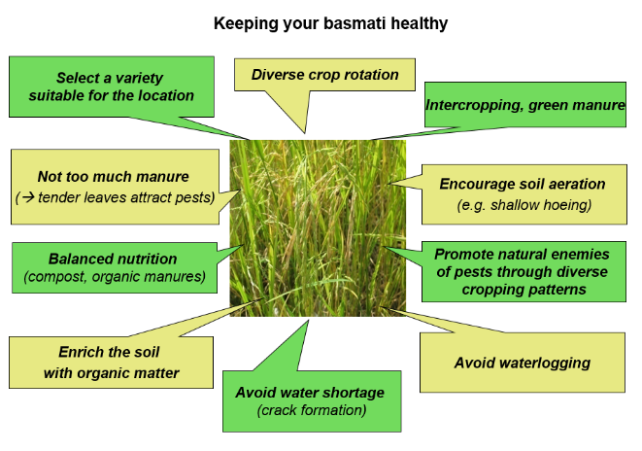A healthy crop is key to avoid pests and diseases. All activities presented below in Figure 8 contribute substantially to keep the basmati crop healthy.

### Prevention and control

Crop rotation, intercropping and the cultivation of trap crops helps to establish a healthy eco-system and to avoid pests to become a nuisance. However, once pest populations or disease occurrence exceeds a healthy balance direct control measures become necessary.

For pests this can be physical removal of the pest by solarisation or flooding, or biological control by pathogens, natural enemies or predators. Moreover, biopesticides also help to control pest populations.

For soil-borne diseases soil management, such as deep ploughing, rouging and weeding helps to prevent diseases. For seed-borne diseases the use of resistant varieties or seed treatment by bioagents is recommended. Moreover, foliar spraying of bio preparations or natural extracts reduces the spread of diseases.

### Important pests

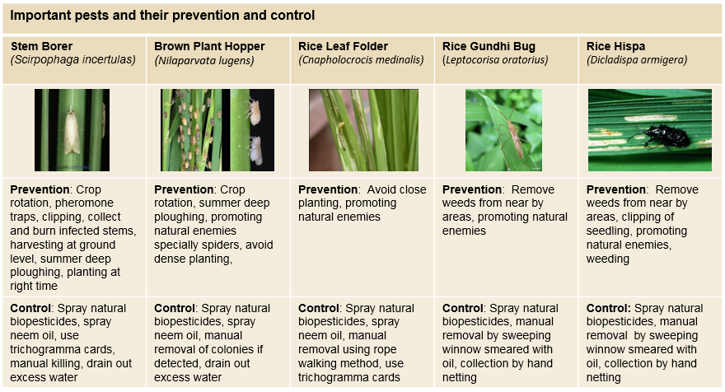The following five insects are important pests in basmati production: stem borer, brown plant hopper, rice leaf folder, rice gundhi bug and rice hispa. Prevention and control measures for each of these pests are presented in Table 5.

Table 5: Important pests and their prevention and control

### Important diseases

The following five diseases are important in organic basmati farming: neck blast, bacterial blight, sheath blight, rice leaf blast and narrow brown spot, see Table 6. Crop rotation, field sanitation and the use of resistant, clean and healthy seeds helps in disease prevention.

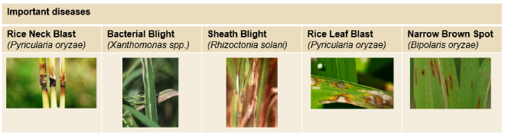

Table 6: Important diseases

### Biopesticides

Figure 9 presents the making of natural biopesticides which helps to control all five basmati pests; stem borer, brown plant hopper, rice leaf folder, rice gundhi bug and rice hispa. Spraying of neem oil also helps in preventing the first three pests; stem borer, brown plant hopper and rice leaf folder.

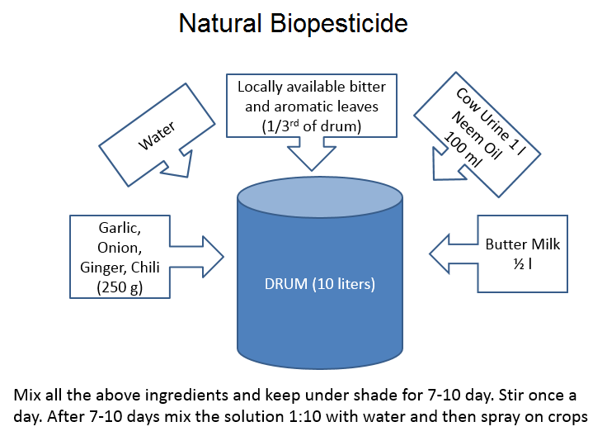Spraying biopesticides and neem oil is best performed at 15 day intervals starting from tillering to flowering of basmati. Normally 1 - 1.5 tanks (=15litres) of natural biopesticide suffice for the control of one bigha basmati.

### Biopreparations

Biopreprations, as described in Figure 10, help to control pests (stem borer, brown plant hopper, rice gundhi bug and rice hispa), diseases (rice neck blast, bacterial blight, sheath blight and rice leaf blast) as well as Khaira – yellowing due to zinc deficiency. Biopreparatonis sprayed at time of pest and disease occurrence, normally 1 - 1.5 tanks per bigha.

Figure 10: How to make bio-preparation

Figure 9: How to make natural biopesticides

## Harvest and post-harvest

**Harvesting**: As soon as grains are mature, but when stalks are still green - usually by mid to end of October - the basmati crop should be harvested to avoid shattering and sun cracks. To test if the grains are mature one can use the *Moisture Meter*. Traditionally, farmers bite the grain between the front teeth. If the grain is cut or chewed it is still not mature, whereas if it breaks with sound then it is considered ready for harvest.

**Key points of harvesting**

* Remove before the harvest off types and plants to avoid mixing and contamination.
* If plants have turned golden yellow harvesting can usually be done.
* Don’t wait for full maturity as it may shatter the grains.
* Clean the harvesting tools and places properly to avoid mixing and contamination.

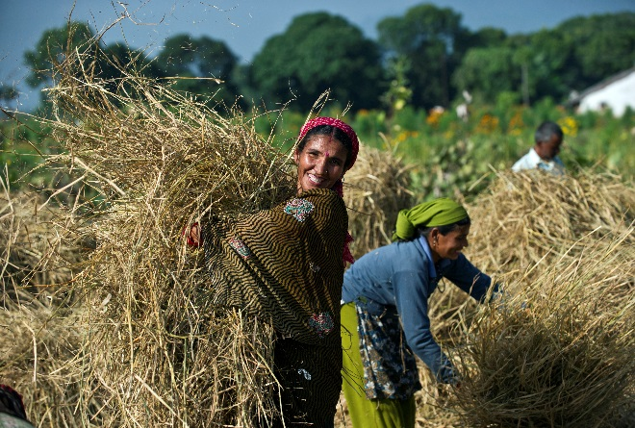

**Drying:** Immediately after harvest the crop is spread in the field for drying, around 2 to 3 days. This step is done to bring down the moisture content to 14%. Here again, the moisture content is detected by a *Moisture Meter* or by the biting method. It is also important to protect the harvest from rains or direct contact with moisture.

**Threshing:** The harvest is collected and threshing can start. Threshing needs to be done on a clean sheet or floor and is usually performed by beating action. After threshing the grain is winnowed, cleaned and graded. After threshing the crop may again be dried before being packed.

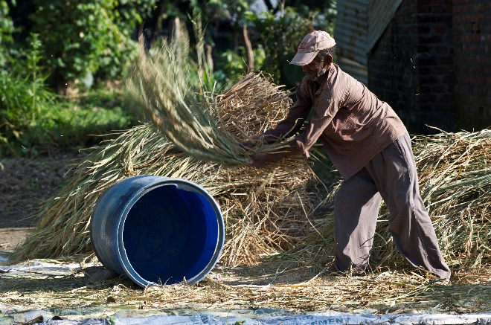

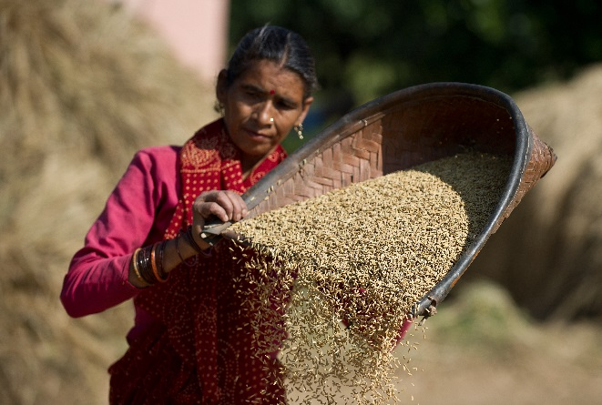

**Storage**: Basmati is stored in clean gunny bags. Use either new gunny bags or bags supplied by the project. The bags are stored separately in a dry cool area. At the bottom of stacks wooden planks protect the gunny bags from moisture. Moreover, never forget to put tags on the bags for identification.

Once the project announces the date of aggregation and procurement, the bags are brought to the central collection centre. Pay attention to check the weighing balance and correct calibration.

# System of Rice Intensification (SRI)

The System of Rice Intensification, known as SRI, is based on the principle *growing more with less*. SRI involves a set of farming practices which help to increase productivity and at the same time reduce inputs of seeds, water and labour.

**1. Seedlings are transplanted at a much younger age** -between 8 and 15 days old - to enhance their potential for tillering and rooting.

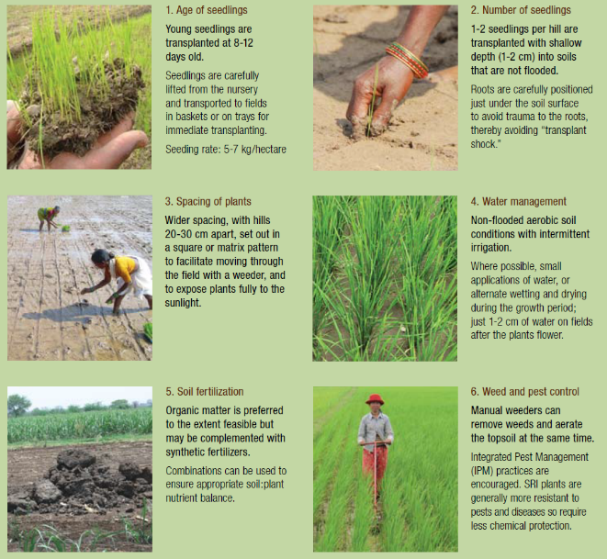**2. Single seedlings** - instead of a handful – **are planted very carefully and gently.**

Figure 11: The principles of System of Rice Intensification SRI (WWF-ICRISAT, 2010)

**3. Plants are spaced wider apart, and in a square pattern**-at least 20 x 20 cm and in some cases even 50 x 50 cm.

**4. Alternate wetting and drying method is used** instead of continuous flood irrigation.

**5. Rotary weeding with a cono-weeder is used** to control weeds and promote soil aeration.

**6. Increased use of organic fertilisers** to enhance soil fertility.

If well done, SRI increases yields, improves rice quality, reduces the use of water for irrigation, reduces labour for weeding, and reduces production costs.

# Diversifying farming systems

Diversifying farming systems by crop rotation and intercropping is key in organic farming. Crop rotation promotes biodiversity, improves soil fertility and contributes to a healthy crop.

For planning crop rotation it depends which crops a farmer wishes to grow. Table 7 suggests three crop rotations suited to the local conditions and farming practices with soy bean, basmati, wheat and pulses/vegetables being the most important crops. The main principle of crop rotation is to rotate between cereals (basmati, wheat etc.) and pulses. Pulse crops fix nitrogen to the soil which benefits the following crop. Rotating crops also prevents the build-up of pests, diseases and weeds, and it maintains balanced nutrient contents in the soil.

Basmati is always grown in Kharif season (June - October). In Rabi season (November - March), it is ideal to grow a pulse with the ability to fix nitrogen. This could be chickpea, lentil or green pea. Vegetables like chili, onion and potato are also Rabi crops (basmati/pulse+vegetable rotation).

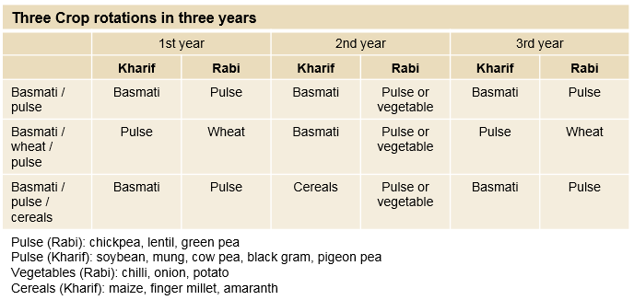Soybean can be grown with basmati in a three years crop rotation with wheat in Rabi season (basmati/wheat/pulse+vegetable rotation). As basmati and wheat are from the cereal family, it is of upmost important to include sufficient pulses or vegetables in crop rotation to support a healthy soil.

Table 7: Examples of three locally suited possible crop rotations over three years

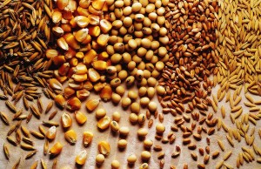

## Organic soybean farming

Soybean is the second main cash crop for organic basmati farmers in India. Soybean is not only relevant for household food security but can also be sold as organic. Soybean is a leguminous crop that fixes nitrogen from the air, thus contributes substantially to improve soil fertility. Soybean is like basmati a Kharif season crop, grown from end of June to mid-October. Soybean can also be intercropped in basmati (see *2.1.5 Intercropping*).

If vermi-compost is available, 2-3 quintalsper bighaare applied in the standing crop after first weeding.

### Varieties and seeds

In the market bold seeded soybeans with yellow headare demanded, thus PK-1042, VL Soya 47, VL Bhatt 65 are suitable varieties.

Use only seeds supplied by the buyer or from own seed production!

Before sowing, the soybean seedis inoculated with beneficial microorganisms. For 5kg soybean seed use 125g Rhizobium, 125g PSB and 50g Trichoderma, mix all in 0.5 litre water and add 50g jaggery (raw cane sugar). The seeds are dried in shade for 1 - 1.5 hours before they are ready for sowing.

### Land preparation

The field is ploughed in dry condition at mid to end of June. Sufficient compost needs to be applied, ideally 10 - 20 quintals per bigha. The field is levelled and proper field boundaries are made if the field is surrounded by conventional fields.

### Sowing

5kg soybean seeds are sown per bigha. Soybean is sown in 10cm distance in rows of 45cm distance and 3 – 4cm deep into the soil.

### Irrigation

The soil needs to be kept moist during plant growth and irrigation is needed at the critical stages of the crop or if long drought occurs. In order to avoid water logging, drainage needs to be ensured during heavy rains.

### Weed management

Three weeks after sowing a first manual weeding is required and repeated 2-3 times in three weeks intervals.

### Pests and diseases

Major pests in soybean farming are white grub, bihar hairy caterpillar, pod borer and aphids. Major diseases are yellow mosaic, anthracnose, bacterial blight, root rot and mildew disease.

To control pests and diseases biopesticides and biopreparations can be used (see Figure 9 and 10, page 19) whereas light traps help in controlling bihar hairy caterpillar.

### Harvesting and post-harvest

As soon as pods become brown and leaves yellow (usually by mid-October) soybean is harvested. The pods are dried under shade on a clean concrete floor or plastic sheet.

The soybean harvest is put in clean gunny bags provided by the buyer or in new polybags. It is advisable to keep dried walnut leaves in the bag to protect the soybean from pests.

## Organic wheat farming

Wheat is another important crop, grown in Rabi season. For wheat cultivation the soil needs to be well drained and its pH value is best between 6.5 and 7.8. There are two strategies in wheat cultivation, timely sowing in early November or late sowing in early December.

### Varieties and seeds

If vermi-compost is available, 2-3 quintalsper bighaare applied in the standing crop after first weeding.

Recommended wheat varieties for timely sowing in November are VL-719, VL-738, HD-2380 and UP 2584, whereas HS 295 and HS 420 are better suited for late sowing in December.

### Land preparation

Immediately after harvesting the Kharif crop, in early November, land preparation for wheat cultivation starts. Best is to mix 6.5 – 13quintals compost (dry) (or13 - 26.5quintalsfresh compost), 33kg neemcake, 33kg rock phosphate and 0.3kg PSB and apply to one bigha.

### Sowing

For timely sowing in November it is recommended to sow 6.5kg wheat seed per bigha (100kg per hectare). For late sowing in December more seed is needed, preferably 8kg per bigha (125kg per hectare). The seed is sown 5 - 7.5cm deep and in rows of 22.5cm distance.

Before sowing, seeds can be treated with Trichoderma, Pseudomonas, Azotobacter and PSB at a rate of 5g per1 kg seed.

Mustard and chickpea can be grown along with wheat. For mustard 33g seeds per bighacan be mixed and sown together with wheat.

### Irrigation

Normally wheat requires 4to5 irrigations in 20day intervals starting at 20-25 days after sowing.If there is limited availability of water, 3 irrigations in intervals of40-45 days suffice.

### Weed management

First weeding is done at 20 days after sowing, a second weeding at 40 days after sowing, either manually or by weeding machinery.

### Pests and diseases

For stem borer control pheromone traps can be used, 1 pheromone trap per hectare at 45 days after sowing.Moreover, spraying a solution of 1 litre cow urine and 1 litre neem oil mixed in 20 litres water also helps in pest control. To control armyworm(“sainikkeet”)use 50g *Bacillus thuringiensis* per bigha (750g per hectare) and apply when eggs start hatching.

For rust disease, spray 5 litres sour butter milk diluted in 200 litres water as soon as the disease is observed. For smut disease, the infected plant (ears) need to be covered with a paper bag before the entire plan is removed and burned. To control smut disease a solution of 5 litres milk and 1 kg mustard power in 100 litres water also helps, if sprayed when ears emerge.

### Harvesting and post-harvest

Wheat is harvested when stalk and leaves become yellow and the plant is dried. Wheat is dried in the sun on clean plastic sheets before it is threshed manually or by a properly cleaned threshing machine. The wheat is stored in clean gunny bags in a dry and clean place.

# Farm economy

## Improving farmer’s income

Farmer’s income from a crop depends on the yield, the market price and the costs of production. In simple words, the net income is the money received (yield x price) minus the money spent (production costs), see Figure 12.

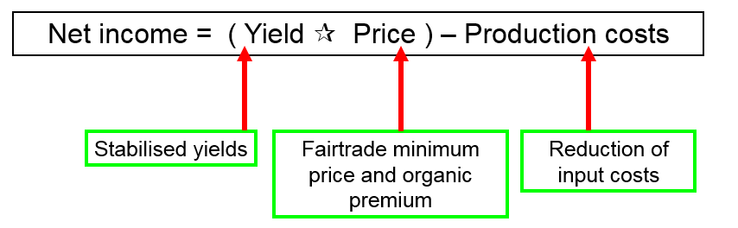

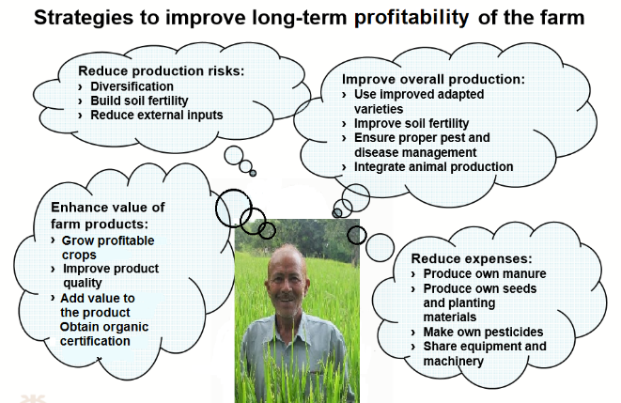

There are 3 ways a farmer can increase his or her income:

* By increasing crop yields through improved crop management.
* By reducing costs of production, especially for external inputs.
* Or by getting a better price for the product by enhancing its value, through better market access, organic premium and Fairtrade minimum price.

Figure 12: Net income equation

Figure 13: Improving the long-term profitability of the farm (adapted from FiBL, 2011)

Moreover, reducing the risk of production, especially of crop failure helps to sustain the income. The risk can be reduced by diversification of crops and income, but also by reducing external inputs and thus production costs, see Figure 13.

## Record keeping

Proper record keeping helps to calculate the income and to improve profitability. Farmers need to record for each crop the quantity of product sold, the price obtained and the total money received, see Annex *9.2 Record keeping*.

All expenditures made for external inputs also need to be recorded properly, including the type of input, the amount and the price. Every time a farmer buys a product on the market he or she must record the amount of money spend. The sum of all bought inputs gives the total money spent. Moreover, the costs for hired labour need also to be included in the expenditures.

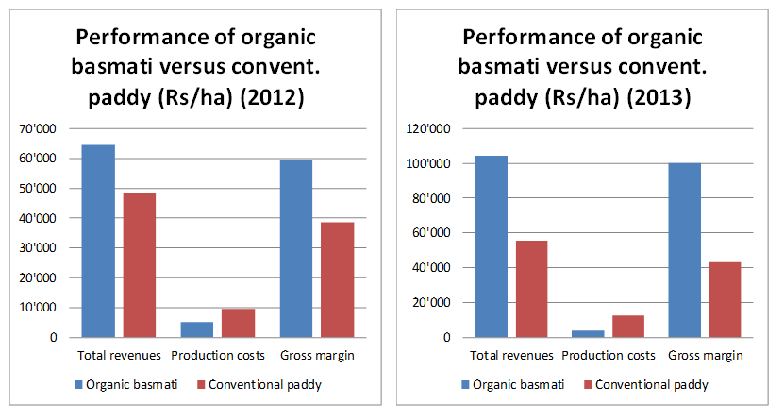

With these data from record keeping it is easy to calculate roughly farmer’s income, see *5.1. Income equation*. For more detailed calculations, depreciation of investments and farm own labour need to be included.

## Profitability of organic basmati

Basmati being a traditional fragrant rice variety has lower yields than hybrid paddy but fetches a higher price in the market. In a survey, organic basmati cultivation was in combination with a 20% organic premium and 50-70% lower inputs costs,50-130% more profitable for farmers compared to conventional hybrid paddy cultivation (based on surveys among 80 organic and 80 conventional farms in 16 villages), see Figure 14.

Figure 14: Economic performance of organic basmati and conventional paddy production in 2012 and 2013

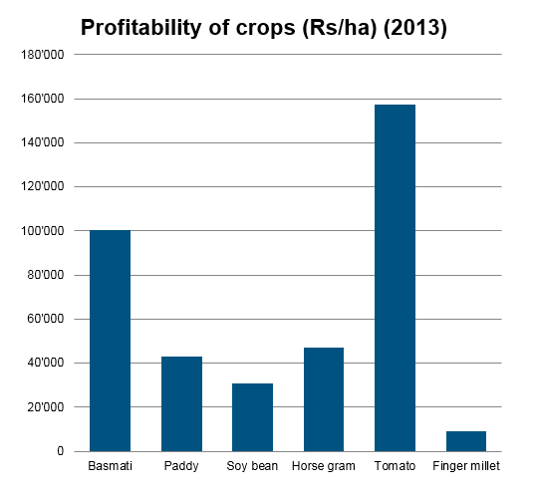This shows that organic basmati production is not only less damaging to the ecosystem but also economically viable. Comparing to other crops only tomato production shows higher profitability than organic basmati production, see Figure 15. However, the investments needed and the risks involved in production and sales of tomato are much higher.

Figure 15: Profitability of crops in 2013

# Certification

## Organic

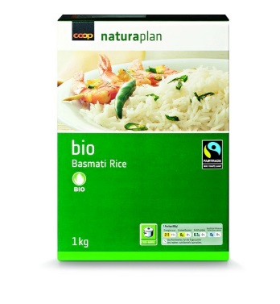Organic certification ensures that the product is truly produced in compliance with organic standards. Organic standards do not define a quality status, but the way how a product is produced. Moreover, the organic standards define minimum criteria to be fulfilled, but not necessarily best practises.

Organic certification gives the producers the opportunity to sell their product at a higher price – the **organic premium price,** see Figure 17**.**

Figure 16: Internal Control Systems and the external certifier (Source: Elzakker & Eyhorn, 2010)

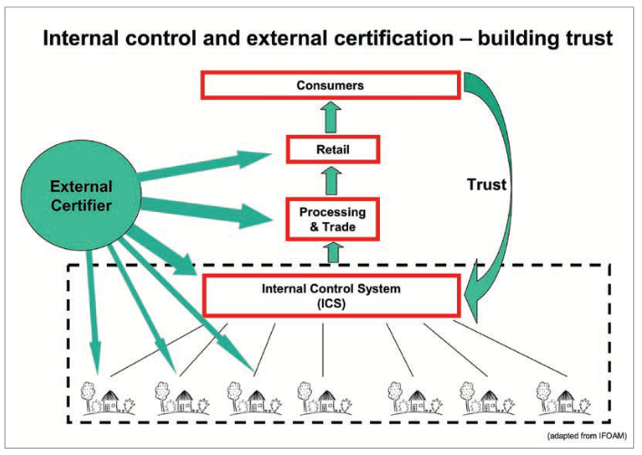The International Federation of Organic Agriculture Movements (IFOAM) is the umbrella organisation for organic production, but most countries and private organisations developed own organic standards. For India the standards are defined under the National Program of Organic Production (<http://www.apeda.gov.in>). However, the organic standards of the target country matter. The regulations in the most important markets are the EU-Regulations and the US-NOP Regulations. In the case of basmati exported to Switzerland the BIO SUISSE standards define the basic requirements to be fulfilled.

## Internal Control System

Producer organisations can be certified based on an Internal Control System (ICS). Each farmer signs a contract with the organisation to declare his or her commitment to follow specific standards. The organisation advises farmers on the specific production practices and helps them in record-keeping, which is central for inspection and certification.

The organisation sets up an ICS and inspects the farm during crucial moments in the production cycle. The ICS, specifically the internal certification committee, also decides about sanctions against defaulting farmers.

At least once a year, an external certifier inspects the functioning of the ICS and re-inspects a certain percentage of the farms at random for controlling purposes. If the external certifier finds defaulting farmers the whole organisation risks to lose its certification.

Therefore, an ICS can only function by trust and cooperation among the involved farmers and between the farmers and the organisation.

## Fairtrade

Fair trade is an alternative approach to conventional trade based on a partnership between producers and traders, businesses and consumers. Fairtrade International (FLO) defines the following basic principles of fair trade:

**1. Social development:** All members of a producer organisation need to have access to democratic decision-making processes and as far as possible participate in the activities of the organisation. The organisation needs to be set up in a transparent way and must not discriminate any particular member or social group.

**2. Economic development**: Buyers pay a **Fairtrade minimum price** and a **Fairtrade premium** to the producers. The producer organisation decides on the use of the Fairtrade premium for community development.

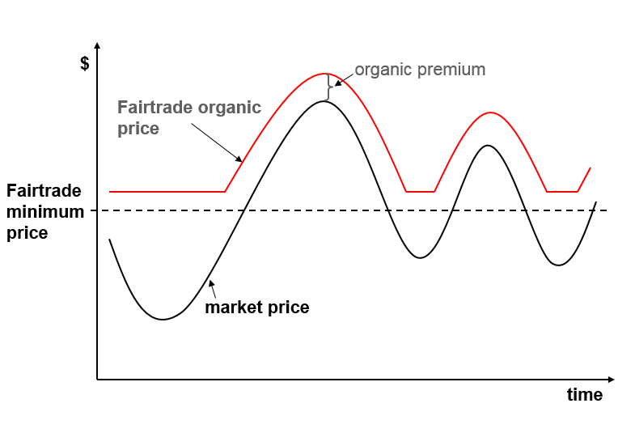**3. Environmental development:** Fairtrade also includes requirements for environmentally sound agricultural practices. The focus areas are: minimised and safe use of agrochemicals, proper and safe management of waste, maintenance of soil fertility and water resources and no use of genetically modified organisms. Fairtrade standards however do not require organic certification.

**4. Forced labour and child labour:**Both are prohibited in the Fairtrade standards.

The Fairtrade standards for small producer organisations and Fairtrade can be found on the FLO website.

Figure 17 presents the pricing according to organic and Fairtrade certification. Inspection and certification by an independent third-party ensures that products labelled organic and Fairtrade really fulfil the requirements of the standards.

Figure 17: The Fairtrade organic price (Source: Elzakker&Eyhorn, 2010)

# Role of women

Women play an important role in organic farming in India. Women are predominantly involved in the care of animals and the management of manure. Moreover, theyplay key roles in many activities around basmati production, such as sowing, transplanting, weeding and harvesting. Men are usually responsible for land preparation, intercultural operations and application of organic fertilisers and pesticides. Unfortunately, they still take most decisions with regards to farming.

Organisations working in organic farming should ensure inclusiveness of women and men and encourage women to participate in training activities, meetings and decision making. Extension services need to pay attention to gender aspects and also reach out to women farmers. Female staff in the team, and female farmer representatives may help to achieve these aims.

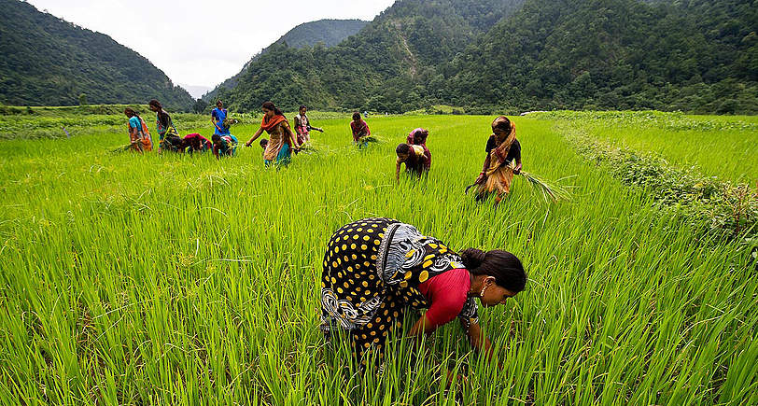

# References

This Organic Basmati Crop Guide bases strongly on following very useful references:

* Africare, Oxfam America, WWF-ICRISAT Project, 2010: More Rice for People, More Water for the Planet.WWF-ICRISAT Project, Hyderabad, India.
* Bo van Elzakker, Frank Eyhorn, 2010: The Organic Business Guide. Developing sustainable value chains with smallholders. 1st edition. IFOAM.
* CCAFS, 2014: Info Note, Alternate wetting and drying in irrigated rice, Implementation guidance for policymakers and investors, by Meryl Richards, B. Ole Sander, April 2014
* Chandra K, 2005: OrganicManures, Regional CentreofOrganicFarming, India
* Farming matters, 2013: SRI much mor than more rice, small-scale agriculture for a sustainable society 03/2013 -29.1
* D. K. Singh and K. P. Raverkar (2009): JaivikFasalotpadanTakneeki (Organic Production Technology) (Edited). GB Pant University of Agriculture and Technology
* FiBL, 2011: African Organic Agriculture Training Manual, Module 9: Crop Management, Chapter Rice
* Frank Eyhorn, Sari G. Ratter, Mahesh Ramakrishnan, 2005: Organic Cotton Crop Guide. 1st edition. Research Institute of Organic Agriculture FiBL, Switzerland.
* Worldbank, SRI Achieving More with Less, A new way of rice cultivation, Multimedia Toolkit

**Useful links:**

* International Federation of Organic Agriculture Movements (IFOAM)

<http://www.ifoam.org/>

* BIO SUISSE

<http://www.bio-suisse.ch/>

* Fairtrade International (FLO)

<http://www.fairtrade.net/>

* SustainabilityXchange - your community in sustainable trade

<http://www.sustainabilityxchange.info/>

# Annex

## Work Calendar



## Record keeping

